Lab 2

PART A
Instruction: Answer all questions.

- Mr. Ragu owns a small scale retail shop which sells stationary. For the past few years, he had been using the Excel sheet file-based system to record his sales and inventory. However, as his business grows, he found that this method of recording sales and inventory is inefficient. Based on this case, elaborate THREE (3) drawbacks of the file-based system approach.

- Refer to question (1) above, Mr. Ragu is advised to convert his sales and inventory record into using a Database Management System (DBMS). Based on your opinion, discuss THREE (3) advantages of DBMS compare to the file-based system.

- Describe THREE (3) functions provided by DBMS.

PART B - SQL Practice
Instruction: Follow the steps below and create your first database and table. The objective of this exercise is to let you familiarize yourself with SSMS and SQL queries.

- Using Ms.SQL Server,
- Build a database named Lab2
- Open SSMS and connect to local host.
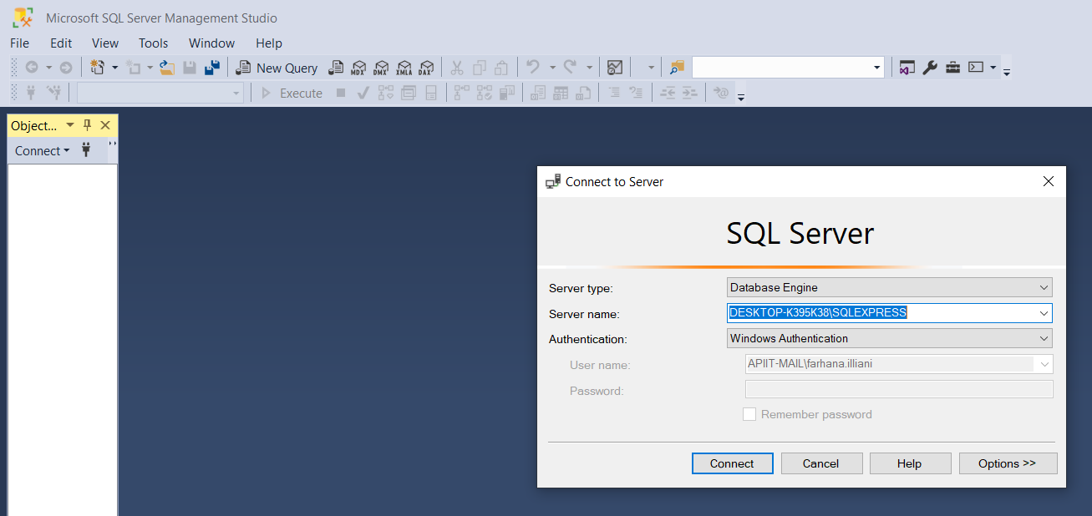

-Expand Databases
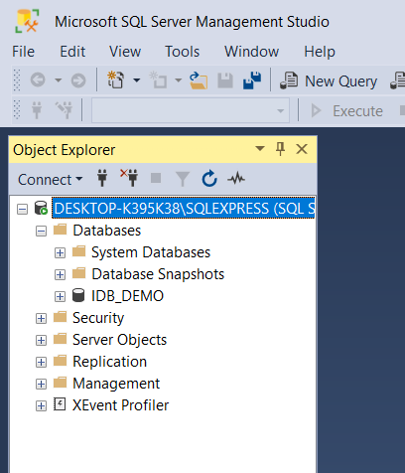

-Right click Databases > New Database
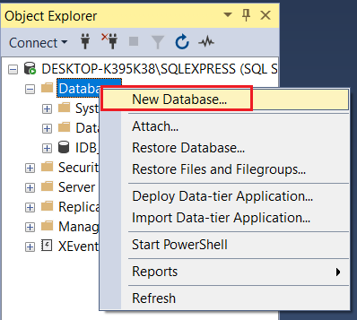

-Type ‘Lab2’ and click OK.

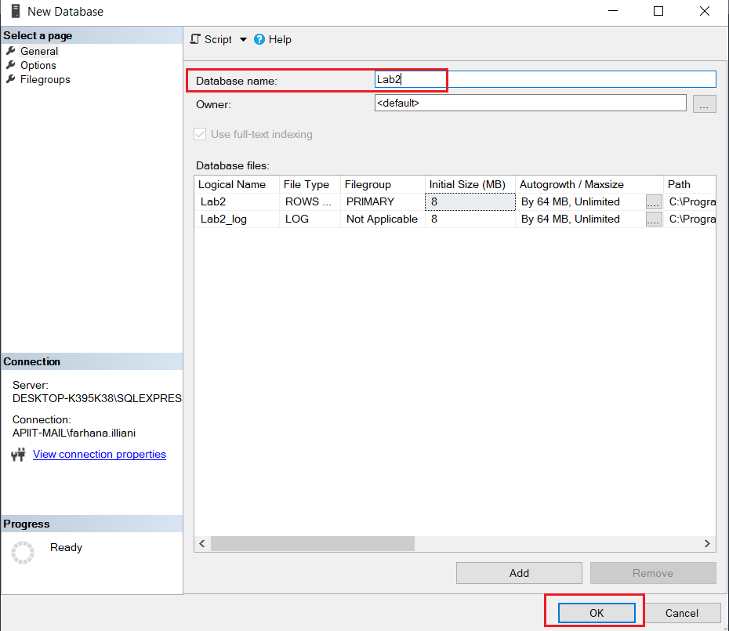

-‘Lab2’ database is created. (If it not appear, click Refresh button)
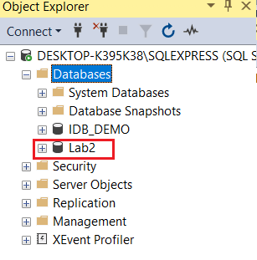

- Create table below and insert the data into the table.

Table Name: Student
StudentID | Name | Gender | DOB | Address
S01 | Ali | Male | 2 Feb 1996 | Kuala Lumpur
S02 | Nancy | Female | 16 May 1997 | Bukit Jalil
S03 | Melvin | Male | 20 Nov 1998 | Selangor

*To create the table, use SQL CREATE TABLE Statement

*To insert data into table, use SQL INSERT INTO Statement

Data Type – use below datatype to create your table.
StudentID | nvarchar(50)
Name | nvarchar(50)
Gender | nvarchar(50)
DOB | date
Address | nvarchar(50)

-Right click on ‘Lab2’ database > New Query. A blank page is displayed.
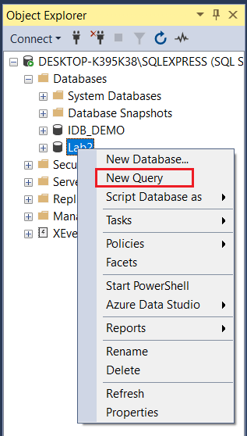

-Follow below SQL query to create the table. Then click Execute button.
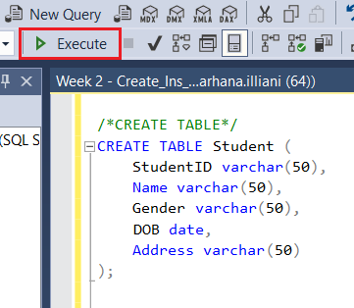

-If it is successful, you will see message like this
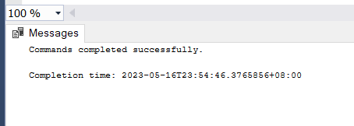

-After table created, you can see the table by writing SELECT query. Type below query > highlight > click Execute button. The table will display on below part. At this moment, you can only see an empty table.

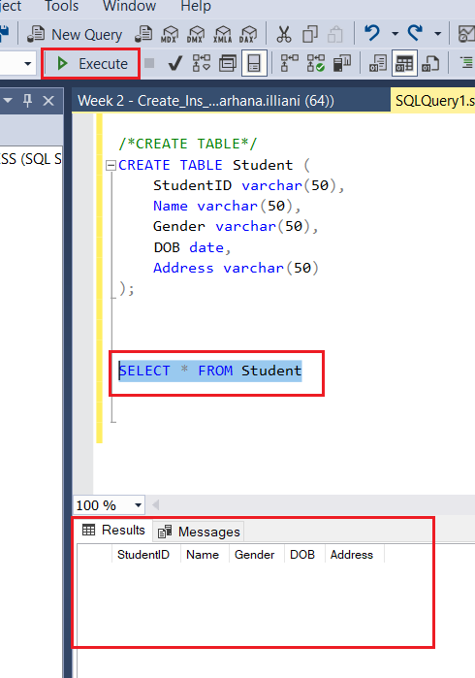

-Next, to insert data into table, use INSERT query. Type below query > highlight > click Execute button.

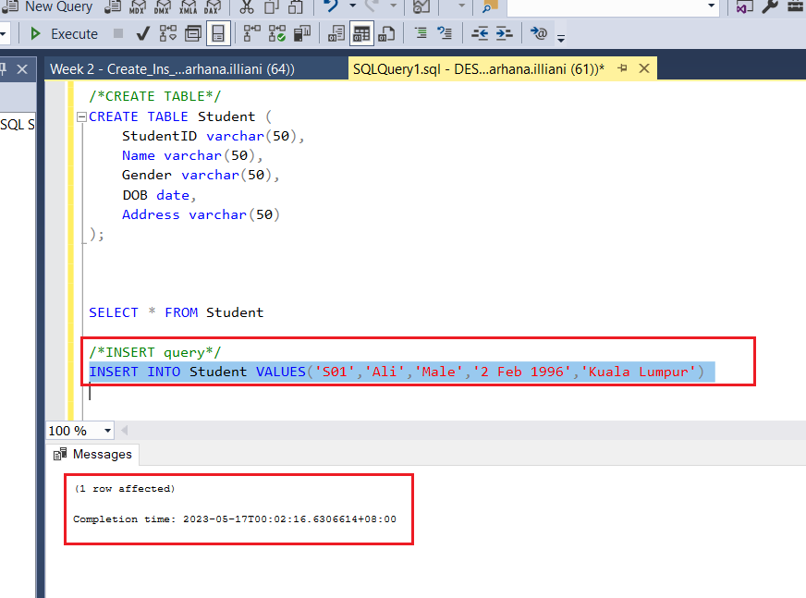

-To view data after being inserted, run the SELECT query again. Highlight SELECT query > click Execute button.
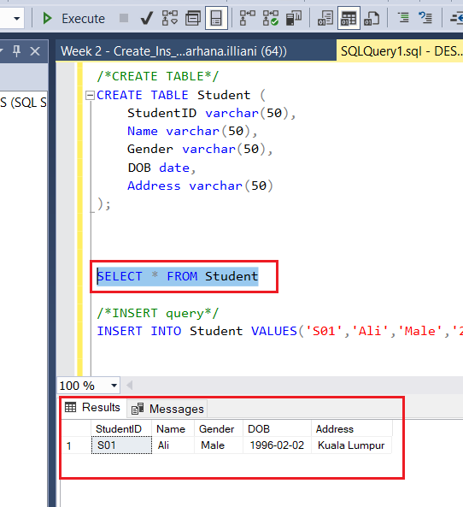

-Refer to question 4(b) you are required to insert 3 rows of data into table Student. You have to repeat INSERT query 3 times, in order to insert 3 rows of data into table. After completed, run SELECT query again. Your final result should look like this:

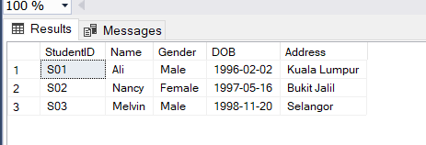

CONGRATULATIONS! YOU HAVE CREATED YOUR FIRST DATABASE & TABLE!

Reference:
https://www.w3schools.com/sql/default.asp

Note:
- Always remember to select the database that you want to work on
- You can issue SQL command in single / multiple lines
- You can insert one row at a time or multiple rows at once
- You can insert data in a particular column or all columns
- It’s a good practice to put a semicolon at the end of the SQL statement
- Always remember to refresh the database after executing a command

